Day 5 Practical: Simulation and inference on compartmental models

Prerequisites:
- Download the BICI software from https://github.com/theITEAM/BICI
- This contains the folder “Edinburgh Course Practical” with the data files used below.
Outline:
In this tutorial you will:
- Learn how to construct and simulate from different types of models in BICI.
- Learn about individual/population-level models and various inference approaches.
Follow the steps below on your own version of BICI…

1) A population-level model
Setting up a simple SIR model:
- A new model can be started by navigating to the “Home” page (on the main menu on the left-hand side) and clicking the “Create model” button in the top right-hand corner.
- BICI allows for multiple interacting species to be added (for example, predator-prey models, or disease vector models). The example here focuses on just a single species. Let’s add one named “Animal” and select it to be population-based.
- Next, we add a classification. BICI allows for individuals to have multiple classifications. For example, they may be classified by their disease status, or their age, or their location. For now, we will set up a single classification called “DS”, standing for “disease status” (don’t worry about all the other options).
- The next job is to add the compartments. This can be done by clicking “Compartment” on the lower menu bar. Let’s set up three compartments called ‘S’, ‘I’ and ‘R’ and give them different colours. The workspace should look something like this:

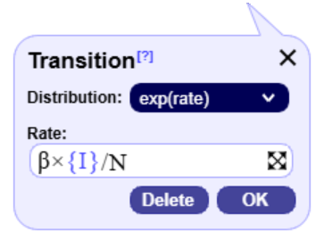
- Now let’s add some transitions. These allow individuals to change the compartment they are in. Select “Transition” from the lower menu bar and click first on ‘S’ and then on ‘I’. An arrow going from one to the other should appear. Attached to this is a panel that gives details of the transition. The “distribution” option sets the type of probability distribution determining the time the individual resides in ‘S’ before moving to ‘I’. The “exp(rate)” option means that there is a certain defined rate with which the transition occurs (i.e. a Poisson process).
- We now set the rate.
Type the following into the textbox: ‘\beta*{I}/N’
Note:
  - The ‘*’ character automatically becomes a times symbol ‘×’.
  - ‘\beta’ becomes ‘β’ (generally, Greek characters are added using this Latex notation).
  - The curly brackets denote “the population of”, so ‘{I}’ represents the total number of infected individuals.
- Notice that there is no ‘S’ in this expression. This is because BICI uses individual rates of transition, not population-wide rates (as are sometimes shown).
- Add in a recovery rate γ and the model should look something like this:
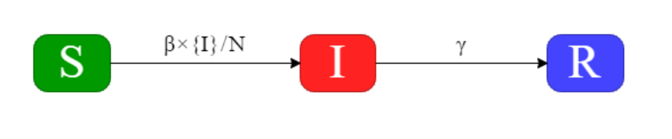
Note, a transition’s properties can be edited by clicking on the corresponding arrow. Give it a try!

Simulation:
- Next, we add some individuals to the model. Click on the “Simulation→Setup” page and then “Init. Pop.”. Click “Next” to indicate that we are setting up a fixed initial population with the graphical interface.
- Click on the different compartments to select how many individuals start in each of them. Set them such that S=1000, I=1 and R=0 (i.e., we are going to look at the effect of a single infected individual entering an otherwise susceptible population). Click “Done” in the bottom right-hand corner to add this information to the model.
- On the “Simulation→Parameters” page set N=1001 (i.e., the total population size, which is fixed in this example), β=0.3 and γ =0.1 (these correspond to an individual taking on average 10 days to recover from infection and a basic reproduction number of $R_{0}=β/γ=3$).
- We now set up the simulation on the “Simulation→Run” page. Select a start time of 0, an end time of 100 days and a time-step of 1 (note, longer time-steps speed up simulation/inference but can lead to discretisation errors).
- Click on “Start” to see what happens…

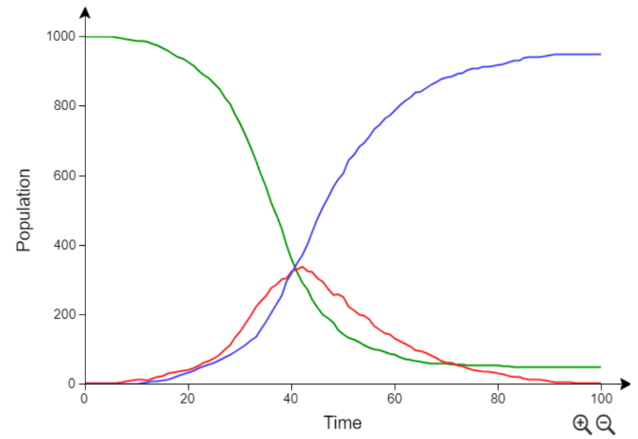
- The output should be something like this, which shows the population variation over time in the three compartments.
- If you are unlucky the first individual just recovered and didn’t start an epidemic. This is called “epidemic extinction”. In this case go back to “Simulation→Run” and simulate again. Every time a simulation is performed the output is slightly different (because of the stochastic governing equations).
- Try looking at different visualisations on the “Simulation→Results” page (e.g. click on the ‘View’ dropdown menu or select between ‘Populations’, ‘Transitions’ or ‘Parameters’ on the main menu.

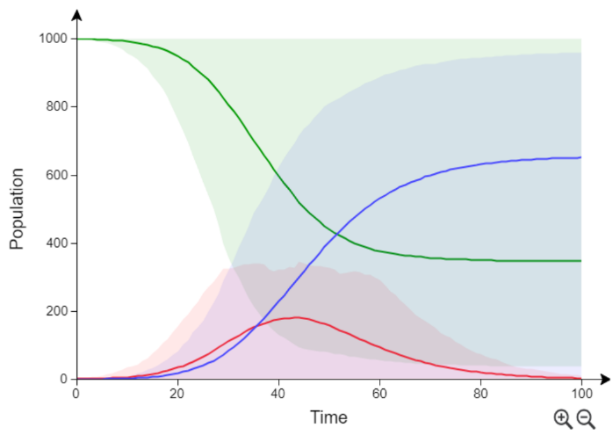
- Go back to “Simulation→Run” and set the simulation number to 100. This produces 100 simulations. The solid lines give the average behaviour, and the shading indicates the region that encompasses 95% of simulations.

- We find huge so-called “stochastic” variability.

Challenges:
Try altering the model and see what happens (just experiment):
- What happens when there is a transition from “R” going back to “S”, modelling so-called waning immunity (note, when you add this transition, you will need to add in extra points along the arrow to go around the “I” compartment).
- Or you could add an exposed state “E” (infected but not infectious) to make an SEIR model.

Inference:
- Next, we look at using data to estimate model parameters.
- As a simple example, we have time-series data giving the estimated infected population every 10 days (giving 10 observations in all) and we want to use it to infer the model parameters.

- Load up the file “Section 1/SIR_model.bici” (this is the model we constructed earlier) by clicking on the menu button in the top right-hand corner.
- Go to the “Inference→Data” tab. This page allows the user to load different types of data. This data could be information about the population makeup, individual-based data (e.g., when individuals undergo transitions or disease diagnostic test result) or population-level data (with many other possibilities).
- Here we need just two sources of data:
  - We need to tell BICI about who is in the population. Click on “Init. Pop.” and then “Next” to add a fixed initial state. Fill in S=1000, I=1 and R=0 and click “Done” (i.e., the same as we did for the simulation).
  - Estimates of the infected population over time. Open the file “Section 1/infected-population-data.csv” in Excel just to see what it looks like. We see that every 10 days an estimate of the infected population is given. Let’s load this data into BICI….

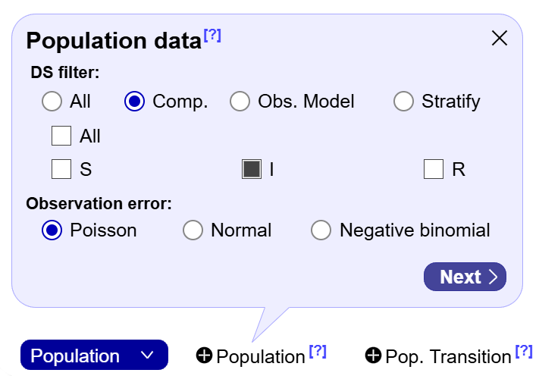
- Using the dropdown button in the bottom-left select “Population” and then click on the button “Population” next to it. We now tell BICI that this data refers to the “I” compartment by clicking on “Comp.” and then checking the “I” check-box (see right).
- Click “Next” and then “Upload” the data file “Section 1/infected-population-data.csv”.
- Select the columns for time and population and click “Next” and “Done” to complete.

- Your data sources should look like this:
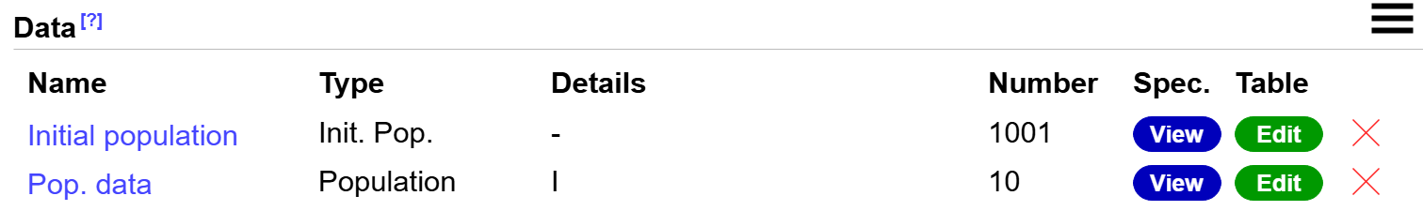

- Now the data has been added, let’s consider the prior. Go to the “Inference→Prior” tab.

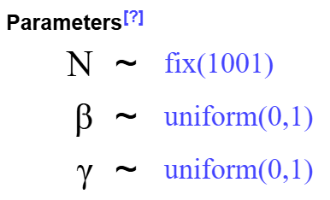
- If we imagine we don’t know much about the disease, the prior is going to be wide and relatively uninformative.
- Let’s select both β and γ to have a uniform prior between zero and one (and N, the population number, is fixed to 1001).
- We start inference by going to the “Inference→Run” tab and fill out a start time of zero, an end time of 100 and a timestep 1.
- BICI gives some different options for how to perform the inference:
Approximate Bayesian Computation (ABC):
- Select the “ABC” option.
- “Samples” here give the number of independent draws from the posterior approximation. By default, 1000 samples are generated but this can be reduced if the algorithm takes too long.
- ABC works by sampling parameters from the prior, simulating the model and retaining only those samples that are closest to the data (by some metric). The acceptance fraction is set to 0.1 by default (which means 10000 simulations are performed and 1000 samples are retained for the posterior approximation).
- Click on “Start” and wait for inference to be completed.
- Explore different ways to view the output.
- Of relevance:
  - Compare the posterior population outputs with the data (found on the “Inference→Results→Populations” tab and selecting “Data” in the dropdown menu on the top right-hand corner).
  - The posterior probability distribution for β (found on the “Inference→Results→Parameters” tab and selecting “Distribution” on the “Graph” dropdown menu).

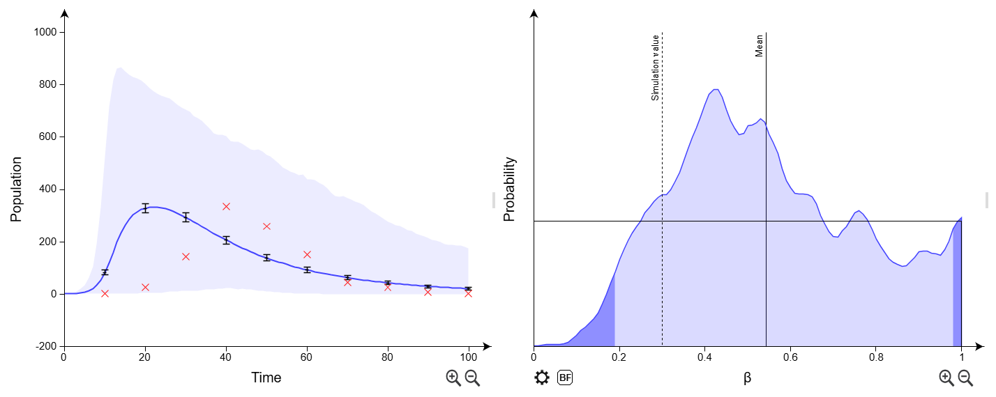
- We find on the left the fit between the data and the ABC results is not very good! Worst still, the estimated posterior distribution for β is almost as wide as the prior (solid black line).
- What do we do? We need to go back to “Inference→Run” and reduce the acceptance fraction, e.g. to 0.01. Here what we get:
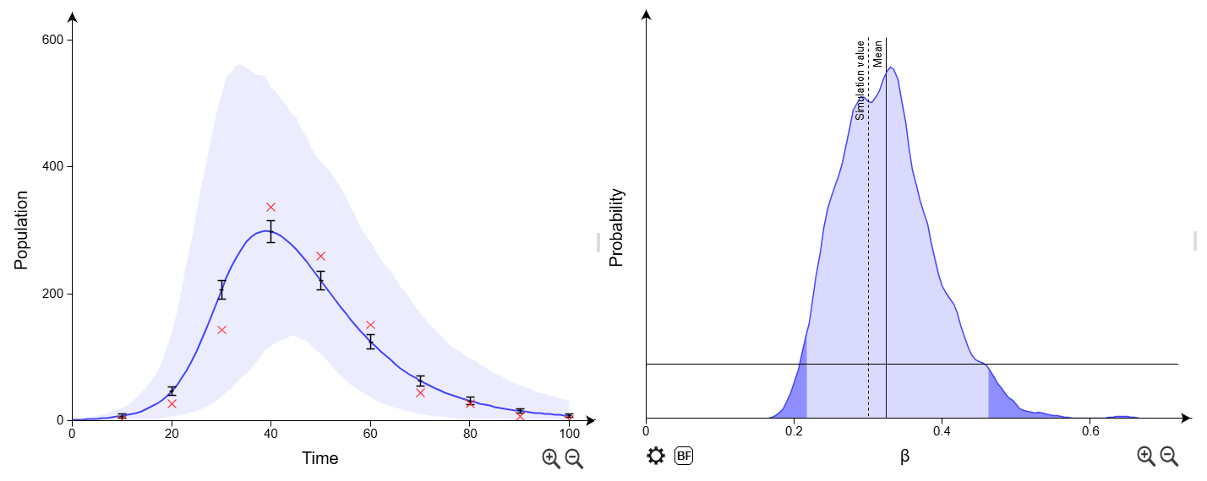
- The agreement is much closer (but still not that great). The data was generated using β=0.3 (the vertical dashed line), so we have, at least, provided a reasonable estimate of that.
- What happens if we reduce the acceptance fraction further? How about the CPU time?
- The key message: Basic ABC becomes very slow due to requiring a low acceptance rate for a reasonable posterior estimate.
- Let’s see if we can do better…
ABC Sequential Monte Carlo (ABC-SMC)
- Go back to “Inference→Run” and select the “ABC-SMC” option.
- Try running the algorithm a few times choosing a different number of generations each time… What do you find?
- The key message: ABC-SMC is faster than ABC because generation by generation it focuses in on a region of parameter space more consistent with the data.
Data-augmentation MCMC (DA-MCMC)
- Finally, go to “Inference→Run” and select the “DA-MCMC” option.
- Notice here that the default number of samples 5000 is much larger than before. This is because, unlike ABC approaches, samples are correlated (and so each is not as informative, hence requiring more of them).
- Also, we introduce the idea of “chains” (3 are run by default). These run in parallel and tell us about how reliable our result are (see below).
- Here are some posterior results (see if you can find these visualisations in BICI):
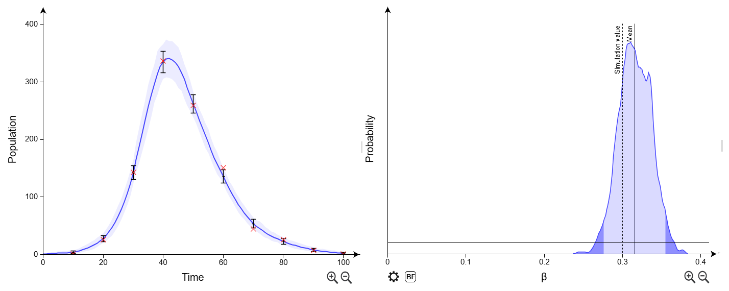
- How do you think these results compare to ABC approaches?
- The key message: DA-MCMC is efficient because it focuses on parameters and dynamics corresponding to the data, but can be inefficient due to highly correlated samples (much research in MCMC is about improving the level of these correlations). Usually, however, it is much faster than the ABC approaches above.

2) Individual-level model with susceptibility variation
- The previous section considered a model that tracks the populations in the compartments over time.
- In individual-based models we give each individual in the system its own timeline. This allows much more flexibility in terms of individual dynamics, analysing individual-level data and individual-level variation.
- Here we consider two types of individual, “a” and “b”, which differ in their susceptibility (e.g. IPN is a disease in salmon in which two variants at a particular genetic location are found to have a big impact on susceptibility).
- AIM: Estimate susceptibility difference from individual-based data.
Set up the model:
- Load up the file “Section 2/two_susceptibilities.bici” (by clicking on the menu button):
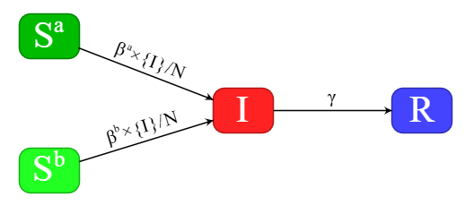
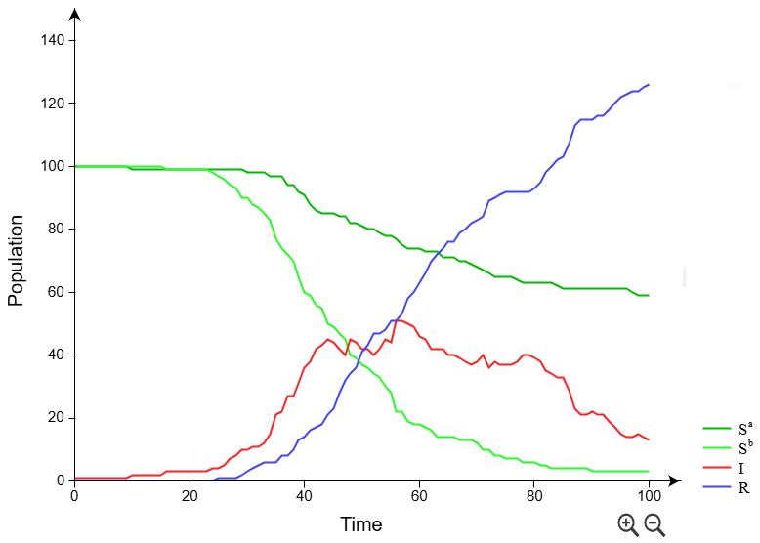
- This model has an initial population $S^{a}=100$,$S^{b}=100$, $I=1$, $R=0$.
- Simulate from this model using some different parameter values. What do you find?
- The example on the right uses the parameters: βª=0.06, β^{b}=0.3, γ=0.05 and N=201.

Inference:
- In this example the data is going to be periodic compartmental observations taken on each individual every 10 days (these are effectively perfect disease diagnostic tests).
- Let’s load some data! Go to the “Inference→Data” tab.
- First, we tell BICI what individual are in the system and what state they start in.
- Click on the dropdown button and select “Init. Cond.” then click the “Add Ind.” button.
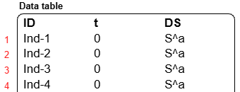
- Select “Load from a file” and “Add”.
- Upload the file “Section2/Individuals.csv” and select columns showing the unique names for the individuals (ID), the time they enter the system (t=0) and compartment they start in (DS).
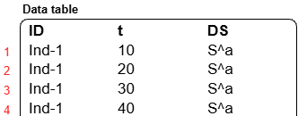
- Click “Next” and “Done” to add the data.
- Now click on the dropdown and select “Individual” (these datatypes all relate to potential individual observations).
- Click on “Compartment”, select the classification “DS” and press “Next”.
- Upload the file “Section 2/Compartmental_observations.csv”.
- This tells BICI the disease status of individuals at periodic 10-day intervals.
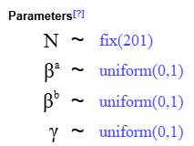
- The prior on right should already be set.

- Run the DA-MCMC algorithm (ABC approaches can’t effectively deal with individual-level data).

- Results: Explore different visualisations of the posterior using the various tabs.

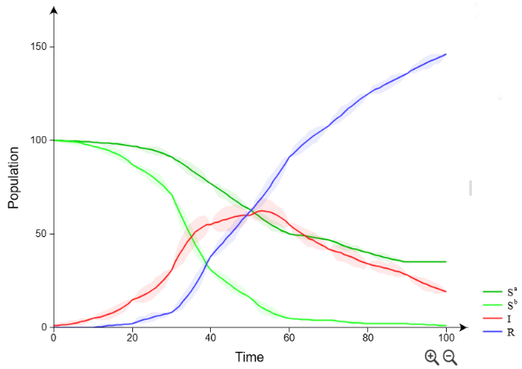
- Find out how to look at parameter distributions and correlations between parameters.

- See right for what the results look like for the populations. The “beaded” nature of the curve reflects the fact that populations are known at 10-day intervals but there is uncertainty between these time points.

- Find information about parameter statistics.
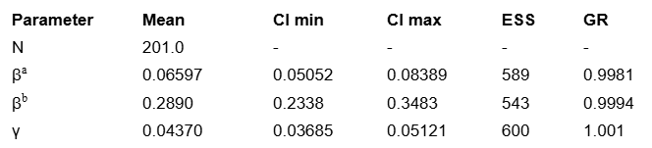
- These give the mean and 95% credible intervals for each of the model parameters.
- The numbers on the right provide important diagnostics as to whether our results are reliable or not. Effective sample size (ESS) tells us how many effectively independent samples from the posterior we have. Since we had 3 chains each running 5000 updates this means the chains are correlated over 3*5000/600=~25 MCMC updates.
- Under the “Individuals” tab we can visualise the individual timelines:
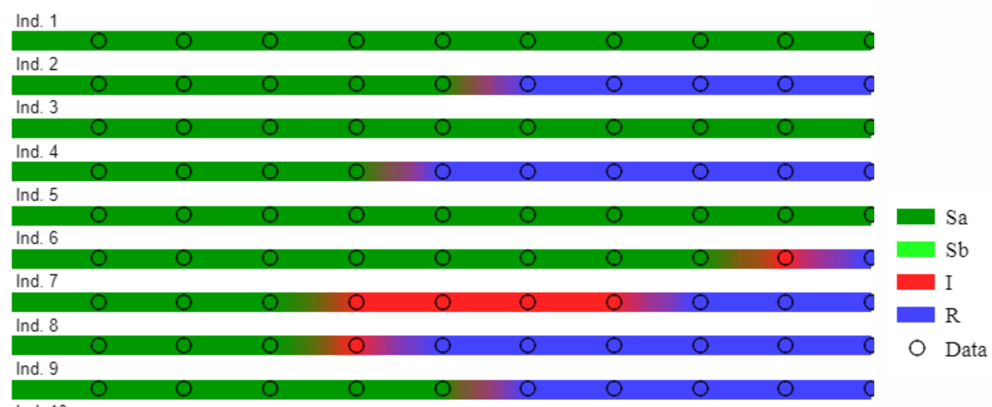
- The colours represent the compartment the individual is in, and the circles represent observed data. There is posterior uncertainty in the precise timings at which transitions occur and this is represented by the smearing of colours.

3) Individual-level model for susceptibility and infectivity variation
- In this example we are interested in extending the model from the previous section by imagining that individual types “a” and “b” differ not only in their susceptibility, but also their infectivity.
- It turns out that to infer both susceptibility and infectivity one fish tank is insufficient; we need two. In fact, an optimal experimental design requires that the first tank contains 83% of type “a” and 17% of type “b”, and vice-versa for tank two.
Setting up the model:
- Load up the file “Section 3/sus_inf_with_data.bici” (by clicking on the menu button):
- The species “Fish” has two classifications:
- “DS” to capture the disease status of individuals:
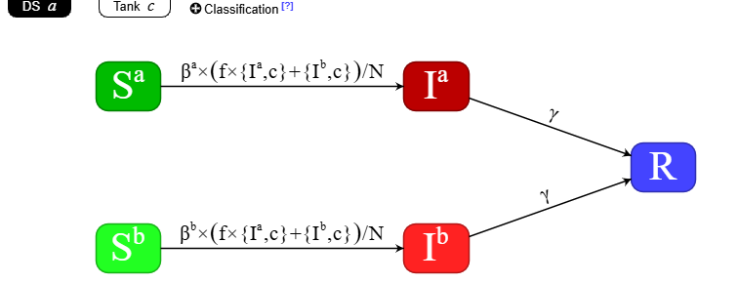
- “Tank” that specifies which tank individuals are in.
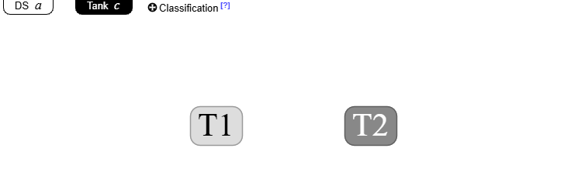
- As in the previous section, the parameters βª and β^{b} capture differences is susceptibility between the two types of individuals.
- The factor f captures how much more infectious “a” individuals are w.r.t. “b”.
- In the notation of BICI, “{Iª,c}” means the population of “Iª” individuals in classification with index c (the tank compartment).
- Have a go at simulating and running inference!

4) Bonus Challenge (if you get time)
- Try to come up with a realistic model of Covid-19.
- What are the key things which characterise this virus and how might they be implemented in a compartmental model?

$R_{0}$ is defined as the expected number of cases directly generated by one case in a population where all other individuals are susceptible to infection.
As a rough guide, provided the time-step is less than ~20% of the shortest mean transition time, the discretisation error should be relatively minor.
Stochasticity is defined as having a random probability distribution or pattern that may be analysed statistically but not predicted precisely. Epidemics are stochastic because they result from random processes, such as random contacts within a large group of individuals.
Pooley, C., Marion, G., Bishop, S., & Doeschl-Wilson, A. (2022). Optimal experimental designs for estimating genetic and non-genetic effects underlying infectious disease transmission. Genetics Selection Evolution, 54(1), 1-22.
Writing simple {Ia} would allow for infected Ia fish in tank 1 to infect those in tank 2, which isn’t right.

